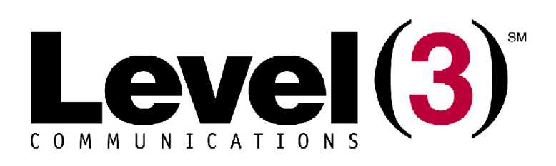

MAINTENANCE

Methods of Procedures

VERSION 2

Last Modified May 1, 2006

Table of Contents

Table of Contents 17
Introduction – Maintenance Request Form 18-19
Personnel & Equipment Required 20
Tasks to be Completed 21
Procedures 21
Back-out Plan and Signature Page 22
Submit Request 83
Revision History 23

Introduction – Maintenance Request Form
This section shall contain an overview / summary of the work to be performed. All of the following fields are required (unless otherwise noted) and failure to submit all required information will lead to a rejection of the MOP.

Requestor’s name: Requestor’s phone #:
Requestor’s group / organization:
Type of Maintenance:
Scheduled: SA PSA NSA
Demand Critical: SA PSA
Requested Start Date /
Date: Time: EST CST MST PST
Requested End Date /
Date: Time: EST CST MST PST
Purpose of Maintenance Activity (if Demand Critical, explain in detail why):
Description of Maintenance Activity:

Location of Maintenance Activity:

Area(s) affected by Maintenance Activity:

Equipment Impacted by Maintenance Activity: N/A

Approval Information
Level 3 Manager’s Name: Michael Wiemer Manager’s Phone #:
Date Maintenance was approved:
Bay State Manager’s Name: Ben Whitaker Manager’ Phone #:
Date Maintenance was approved:
Personnel & Equipment Required
This section shall contain the required personnel & equipment necessary to perform the Maintenance.

Name: Contact #: Location:
Name: Contact #: Location:
Name: Contact #: Location:

Veroxity Maintenance Coordinator & On-site Maintenance Contact

External Personnel (Contractor Information)
Name & Company: Contact #:
Location and Description of Activities:
Name & Company:
Location and Description of Activities:

Tasks to be Completed:
This section shall contain a detailed list of the specific tasks required to complete this Maintenance activity. Please include all supporting documents (tables, graphs etc…) that will provide a clear understanding of all that needs to be accomplished. This information is required and failure to submit all required information will lead to a rejection of the MOP.
- __________ to work with Level -3 to obtain all permits necessary with the City of Boston, prior to manhole(s) entry

- Vendor identification signs to be visible during construction per Boston DPW specifications.
- Set up of underground equipment (materials, manhole cages & blowers, placement trucks, etc.) outside Level 3 Manhole(s) location. Test manholes for gas, and vent prior to access.

- Manhole(s) to have water evacuated from structure prior to entrance if needed.

- Enter Level 3 Manhole(s) to ___________
- All materials to be labeled with 24 hour contact information. Cable/splice case will be secured to the side of the manhole in a neat and clean fashion.

Procedures
This section shall contain the sequential ‘step by step’ instructions for performing specific tasks required to complete this Maintenance activity. Please include all supporting documents, see sections 3.5 thru 3.8, pages 10 and 11, that will provide a clear understanding of all that needs to be accomplished. This information is required and failure to submit all required information would lead to a rejection of the MOP.

Back-out Plan
This section shall contain the sequential ‘step by step’ instructions for backing out of Maintenance and returning all systems to their original configuration, in the event that the above Maintenance process is unable to be completed successfully. Please include all supporting documents (tables, graphs etc…) that will provide a clear understanding of all that needs to be accomplished.

- Note: If back-out plan was initiated, please immediately communicate to Bay State.

- If work must cease the splice case will be sealed and dressed accordingly.
- The manhole closed.
- All vehicles will be removed from street.
- Return time coordinated with Inspector
- A detail will be present at each Manhole at all times.
- A new MOP with the new dates and times and detailed description of activity to be submitted to Bay State.

1. If work is to stop for any reason the splice case will be put back in the hole and secured neatly to the manhole wall
2. The level-3 manhole will be closed.
3. Veroxity will submit a new MOP outlining new process with new dates and time lines.

By acceptance of this MOP, the requestor agrees to pay all JTP Network Administration fees incurred by Bay State with respect to inspection and as built revision services associated with the MOP SOW.

_____________

Requestors Signature

Name / Title

__________________
Date

Submit Request

E-mail the completed MOP and associated documents (if applicable) to:
bwhitaker@baystatens.com

